Project Design Phase-II

Data Flow Diagram & User Stories

|  |  |
| --- | --- |
| Team ID | PNT2022TMID17630 |
| Project Name | Smart Fashion Recommender Application |

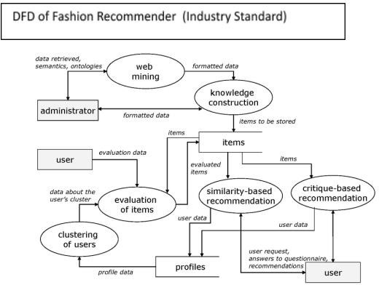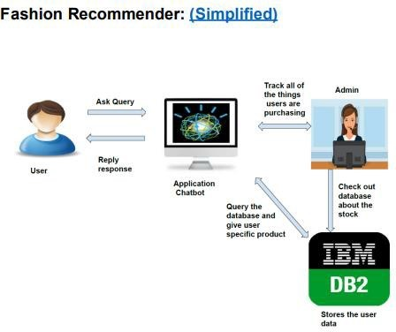

User Stories

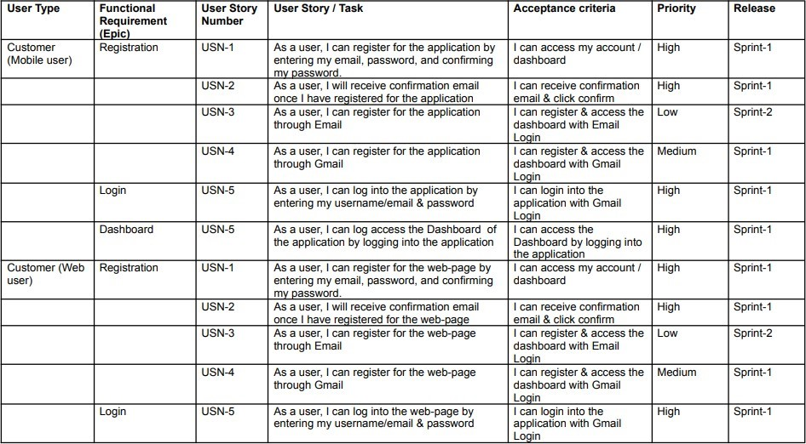

|  |  |  |  |  |  |  |
| --- | --- | --- | --- | --- | --- | --- |
| User Type | Functional  Requi11ement  (Epic) | User Story  Number | User Story *l* Task | Acceptance c,riteria | Priority | Release |
|  | Dashboard | USN-5 | As a user, I can log aooessthe !Dashboardby logging into the web-page | IIcan access the  Dashboard by logging into the web-paqe. | IHigh | Sprint-1 |
| Customer Care Executive | Login | USN-1 | As a Customer Care IE ecutive, IIcanlloginto heapplication by entering1my Executive emailid &oassword | IIcanlogin into the application with GmailLoain | IHigh | Sprint-1 |
|  | Dashboard | USN-1 | As a Customer Care IE ecutive, IIcan accessU'1e Dash'boardof the application by logging into the annlication | IIcan access the  Das'ilboardby logging into the annlication | IHigh | Sprint-1 |
|  | Service | USN-1 | As a Customer Care IE ecutive, IIcan accesshe Customer service page of the applllicationby logging and acoessingthe pag:e | IIcan access the Service pagebylogging1&acoessingthe pag:e |  | Sprint-1 |
| Administrator | Login | USN-1 | As a Administrator, I can log into the  app:llicationby entering my Administer emaillid &cassword | IIcanlogin into th,eapplication with Gmail Loqin |  | Sprint-1 |
|  | Dashboard | USN-1 | As a Administrator, I can acoessthe  Das'ilboardof the application by logging1into he annlication | IIcan access the  Das'ilboardby logging intothe annlication | IHigh | Sprint-1 |
|  | Administration &Service | USN-1 | As administrator, I can aocessAdministration &service page of the application by logging1&acoessingthe page | IIcanaccess the  Administration &Servicepage lbylog:ging andacoessincthe JJ_ac:e |  | =- |